### ****Employment Tax Calculator and Payroll Organizer Application****

### Team members: Lucas Torres, Mojgan Ahmadi

## **Overview of the Application**

### ****Employment Tax Calculator and Payroll Organizer**** is a financial productivity tool that allows employment tax computation and payroll management to salaried employees and employees/contractors compensated on hourly basis.

### Identification of the problem and opportunity

* Complexity, labor and paperwork reduction.
* Core employment tax computations.
* Net pay calculation.
* Employer contribution.
* Provides essential set of tax reference data.
* Fully autonomous operations in a stand-alone mode will increase the application mobility/flexibility

The application extends the functionality and UI payroll tax calculator by using a external database to store payroll and tax reference records and data export features (to Microsoft Excel tax forms).

### Intended uses and anticipated audiences

Proposed financial application is intended primarily for use by small and mid-size businesses. This app is about "small business helping the other small businesses". It could also be used by private accounting firms/CPA, educational and research institutions, and Governmental agencies.

Development approach

Development strategy will be based on the maximum re-use of the program.

The tools to be used include Microsoft Visual Studio 2017 for Desktop and auxiliary tools (SQL Server Management Studio, variety of Microsoft Office application and image/video editing software)

Coding Languages, Frameworks and Tools

The code will be developed using C# language and .NET framework/WPF. Database operation on file-based Microsoft SQL Server. Data export operations will utilize Microsoft Office object libraries.

First Tab : Employee Information

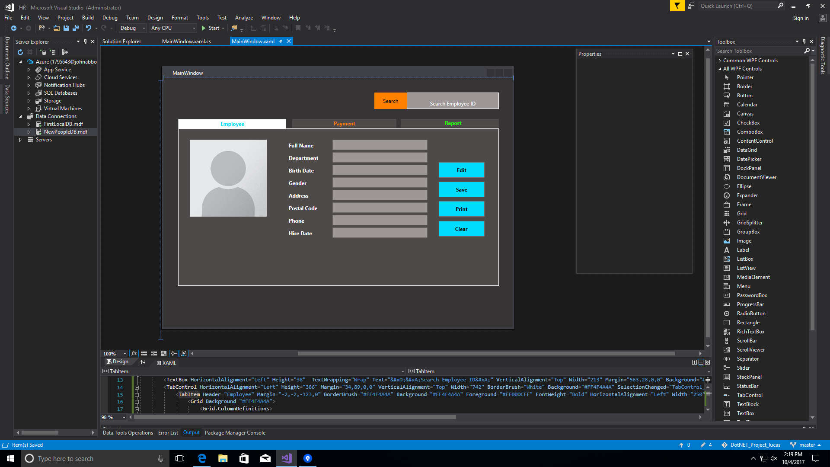

Second Tab : Payment

